Journal Web Design

Name: Alex Garbalyauskas Student Number: X22440482

Introduction:
College project for web design where the main goal is to create a functional web page with multiple pages, a working xml, xslt and schema contents, and a search page that is able to search for the xml data, This is an informative journal entry that documents each weeks work on the project, how the project was worked on, what was developed each week, problems that arose while working on the web project, how each major and minor problem was solved , and other information about decisions made on the project.

Week 1:
For my Web Design project, I started off outlining my ideas within my copy, I sketched out how I wanted my Webpage to look starting off with the index main page, I drew in how the Title, navigation bar, main content, images and symbols will look like on the webpage, furthermore I started brainstorming the theme of the page, knowing I has to create a product page displaying various products I decided on creating a food market webpage. When I had decided what the theme will be I began developing my logo for the webpage, it started with rough sketches, afterwards I found a free website called Canva where you can create free logos. I quickly created my logo; I made it a Cheese logo with the European influences using a blue background and yellow stars to surround my cheese. Then I downloaded my logo from canvas for free using the 30-month free subscription.
Afterwards after finishing my outlining ideas and my logo I began working on the main index page for webpage using HTML and CSS, I began writing in my Title, Header, Navigation links, Main Section, and Footer then started styling it out using CSS, I first started working styling out my Header and title alongside the navbar which I wanted to be all on the top of the page within a single div or within a single square box on the top page, It took a while to figure out I put In the logo first at the side of the of the page, the title header and nav bar in the centre of the page and lastly the search bar button on the right hand side of the page, when that was done I began editing my main section where my paragraphs will be located in. Made it appear in the centre within a white box alongside the blue body background, afterwards I stylized my footer, made it black and put some initials on it. When the overall main page was finished being stylized, I began working on the java code for my navbar, I wanted a side bar navigation to pop up on the side of the screen which you can navigate through different countries and find out about their national cheese products that they have created, this bar would include all the major European countries that have a popular cheese to showcase.
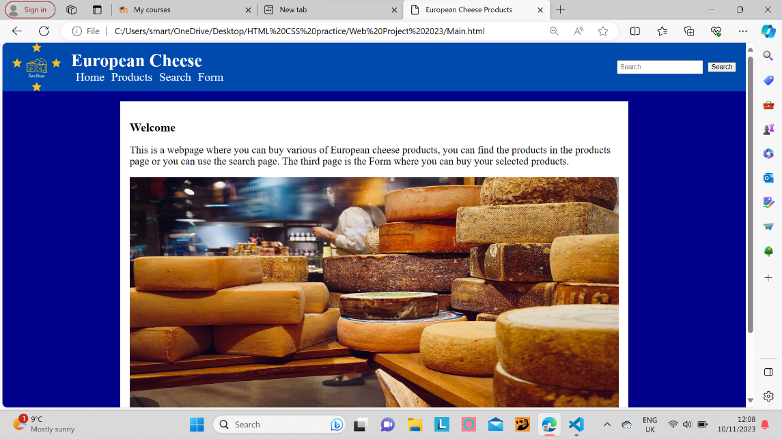
Week 2:
Since I have my main page done, I need an xml file to contain my data that I will be able to showcase on one of the pages on my webpage, which will be searchable also via a search button within the webpage which will send the user to his specified search. The xml file will be used to store data about my products, I created the xml file quite quickly in one day as we were doing many examples of XML during classes, when I finished my xml file I started working on my xslt file which is used to display an xml file on a html webpage such as edge or chrome, this required more thinking but luckily my xml file was quite simple and the xslt file only highlights the parent tags so I used previous in class examples that the class worked to help me create my xslt file, I did this within one day. The most challenging part currently is getting my xml file display its data on a webpage for some reason my xml data wont display on a webpage even when I linked the xml to the xslt it doesn’t showcase, afterwards I found out that I need to link the two into a html file which I did, and it also didn’t work, I had various problems in trying to display the data, after struggling for a while I tried to create an example of xml displaying into the web in a separate file that I use to practice in web design, I created the example, linked the three files together and it still didn’t work. With increasing problems in trying to display it, I decided to leave it for now and work on the html again, this time I created the other pages which you can navigate too from the main page within the nav bar, I created two extra pages the buy products form page which the user uses to buy his products by inputting his details such as name, card details and which product he wants to buy, and the products page where the user will be able to view each product. I only added in my headers, and footer style within these pages for now.
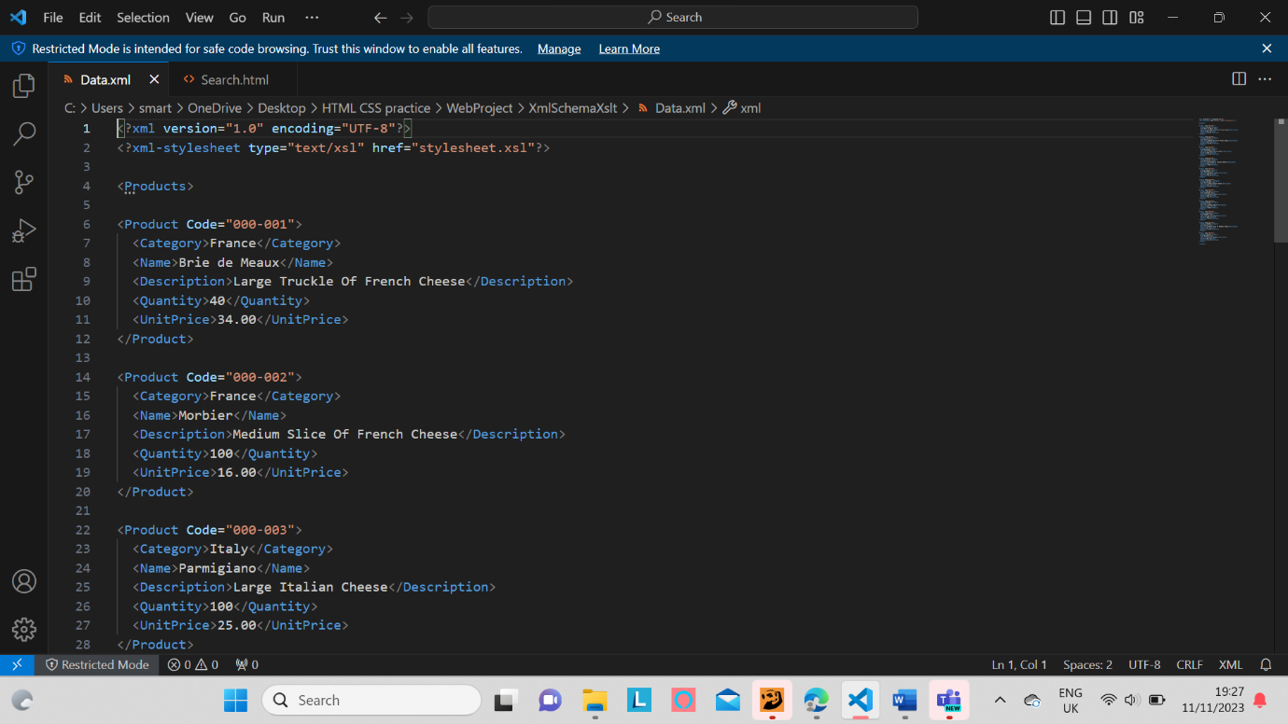

Week 3:
For week 3 I mainly worked on the products page, I decided that the user will be able to select a country via an interactable image, there are 8 countries in total France, Germany, Sweden, Poland, Ireland, Italy, Spain, and Greece, that the user can click on and he gets to view the countries products which has the data from the xml files, from name, price, category, code, description, quantity and an image beside the information that the user can see and have a better understanding of what product he is viewing. Each products category is the products country origin and the code number can be used in the search bar to view the products xml data. Creating this page wasn’t too difficult I had to style the images in the centre of the page in main using CSS I made them an appropriate size and added in the links within the html so when the user clicks on the image he is sent to his products information page, I decided to make each countries products link each own html file so that I can edit in the information that is within the table, I copied the code that I made for my first country and added it to the rest of the countries, so that each tables information is different and has its own image. When I finished my product’s page I started working on an extra web page link called the search page where the user will be able to search for his products via a code, that is displayed in the products page tables and I will add them below the search input button within the search page.
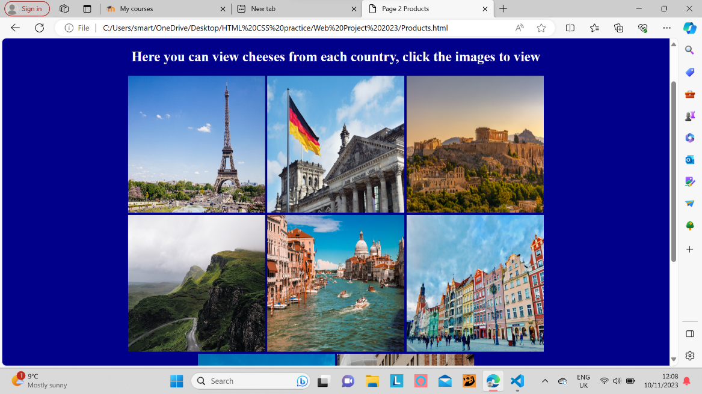

Week 4:
On week 4 I progressed with my form page this page will be where the user can supposedly buy his products with multiple input buttons and text inputs from name, gender, date of birth, and credit card payments via a credit card number text input and a circle check list to select which card to pay with, I styled all the buttons to be within a main div box in the centre of the page. When I finished the form part, I began working on the JavaScript where it has an pop up message asking the user to fill in his form If he submits it blank and a pop up message saying thank you if he does fill in his form, I used previous class examples to do this and I watched a couple of social videos online in helping me create this simple pop up message. This is all I did for week four.
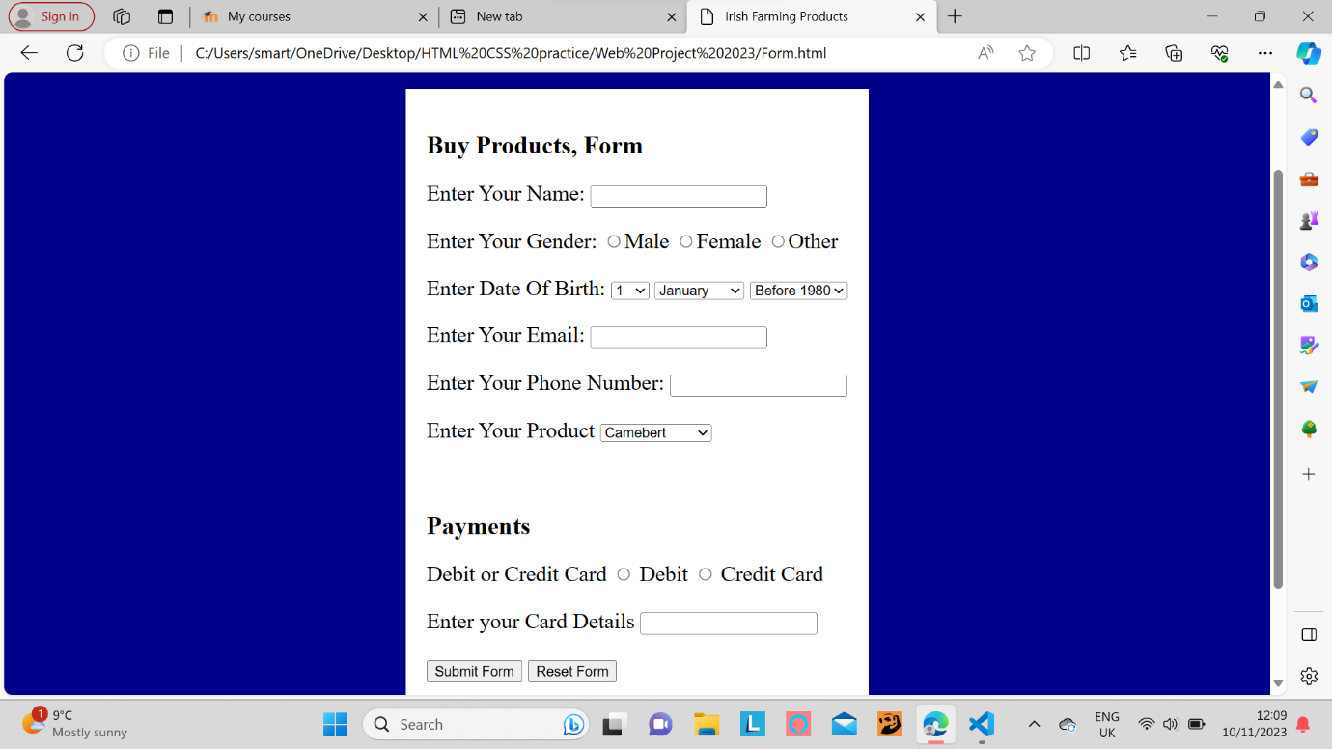

Week 5:
On week five I worked on the xml view page, I finally figured out how to display my xml data onto the html page without it being blank on page, it required me to download a server provider such as Xampp, from there I copied my folder with all my contents to the hct docks folder in Xampp and accessed the server in the Localweb/WebProject, this sent me to a web page server from where I can access my files, in the server my xml worked perfectly, so I continued working with Xampp so that I can continually view my web pages with each detail that I changed within my code. When I finally figured out how to view my xml, I returned to working on my unfinished search page, I used JavaScript to fetch my xml to display it on the page by clicking the button, when I successfully did this I added in the xslt transform into the JavaScript code so that it can display within my edited html table. Doing the search function was increasingly difficult to solve, so I decided to create a separate web page called Xml View where my previous JavaScript Function of just displaying the xml data can be used, and for the search page I will work on it last as I still need help and practice when it comes to creating a search function for each products code and then displaying it.
On the last days of this week I finished my search page, I created a search function which is activated by user text input and a search button, when you click the button it activates the search using the codes that each product has, my function uses a XmlHttpRequest, which extracts my xml data file to be displayed onto the page which uses inner html to display this text, the function is created using the get element by id to connect to the button, and if statements to separate each product code so that they are displayed separately from each other, without it having to be all displayed when you press search. When I finished my JavaScript search function I fixed minor details in each file when it came to the html and CSS, I also decided to organise my files as all my contents where in one file which is hard manage, I added in all the images into one file, the same was done for my html, CSS and journal. When this was finished I got a problem they all had to be linked again and the normal link using the href didn’t work, after researching I found out I need to use my /, so for example if files are all in separate folders you use this ../Images/image.jpg which then searches through your folders and selects the right file. This was a hassle to do, as I had to re edit all my contents so that they can all be linked together but when it was done everything worked smoothly.
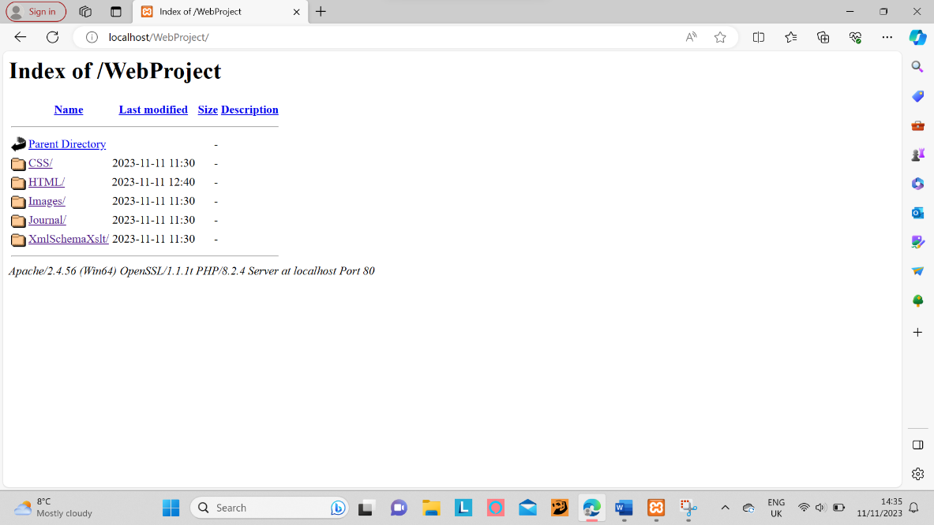

Conclusion:
In conclusion working on this project has made me learn a lot about creating webpages than I had done the previous year of college, it highlighted to me the complexities and challenges that goes through when creating a functional web page especially when it’s comes to the JavaScript with its complex coding and function, creating a functional xml, xslt and schema files which are linked to each other, validated and work, just figuring out how to display the xml into html was a long continuous road of trial and errors which required me to download a server provider just to be able to do this , figuring out how to link folders to one another, having to use CSS to style and manage my html and JavaScript function texts, how to use Xampp the server provider was a long time of researching and asking from other colleagues in how to use the localhost or even how to connect my project folder to it. Overall working on this web project has shown me how many small niche technical difficulties that constantly appears when creating a website, how you need patience and resilience to get through it.

